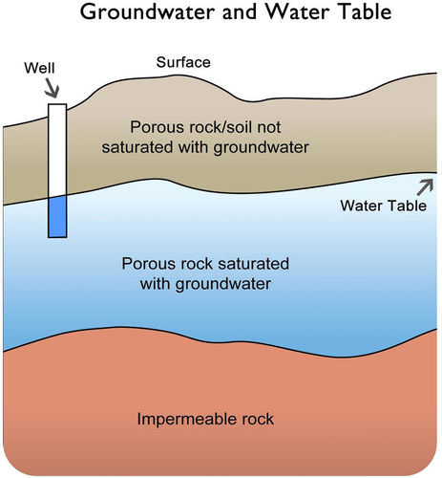**Where does Vanlue’s drinking water come from?**

Vanlue’s drinking water is pumped out of the ground by three wells located in the well field on the north side of town. The ground water is pumped to the water treatment plant where chlorine is added to kill harmful bacteria in it. From there it is pumped through an underground network of pipes to Vanlue’s homes, school, and businesses.

From where does ground water come from? All ground water originally comes from rain or melted snow that has seeped into the ground. Water is stored in spaces between sand and gravel and within fractures in rocks. Where underground water is abundant enough to provide an adequate source of drinking water, the water-rich sediments or rocks are called an ***aquifer***. Vanlue’s drinking water supply comes from a Karst limestone rock aquifer.

Ground water does not stay in one place. The ground water supplying Vanlue’s wells comes from the area shown on the Protection Zones. Since the rock is a Karst type of limestone, this means that if pollutants are spilled on the ground anywhere near the wells, or in the overall protection area of the wells, they may eventually enter the ground water that you are drinking. And although the water treatment plant removes bacteria, it would be very expensive to purchase treatment systems for every type of possible pollutant. That is why everyone in Vanlue should know about “**Drinking Water Protection**.”

**What is Drinking Water Protection?**

Drinking Water Protection is a plan of action for protecting the water you drink from contamination. Your community’s Drinking Water Protection Plan was developed by village staff and community leaders, with guidance from the Ohio Environmental Protection Agency.

The Environmental Protection Agency provided maps delineating Vanlue’s “Drinking Water Protection Area” as shown on other included maps, attached to this document, shown as the inner (light blue) and outer (dark blue) zones. Ground water within this area will reach the village’s municipal wells within five years.

The village has made a list of the activities which are taking place in the Drinking Water Protection Area that involve the use and types of chemicals. More information was gathered about the way they are used, disposed of, and stored. After this information was collected, it was easier to think of ways to help prevent chemicals spills or accidental leaks from happening.

The Village is working very hard to educate its community members about their Drinking Water Protection Area and the importance of avoiding chemical spills within this area. However, Drinking Water Protection is an ongoing concern. Activities come and go. The need for protective actions may change over time. One thing, however, remains true: unpolluted drinking water is one of a community’s most precious and essential resources. Through active, ongoing Drinking Water Protection, it can be preserved for all community residents – today and into the future.